Excel Case

THE POSTAL SERVICE ANALYSIS

Decision Support Using Excel

PREVIEW

The postal service of a large country has been losing money for years. Various operating reforms and financial reforms have been proposed. In this case, you will use Excel to examine whether the proposals can restore the postal service to financial health.

BACKGROUND

A large country’s postal service has been losing money for years. The postal service is officially a private entity, but the government oversees its finances and operating decisions and provides loans in the case of cash shortfalls. The postal service faces serious challenges. Proposed operating changes and financial changes need approval from appropriate unions and the legislature before they can be implemented.

Challenges
The postal service has been hurt severely by the rise of the Internet. Every e-mail sent is a letter not written and a first-class stamp that was not purchased from the postal service. Also, the postal service’s shipping business has been hurt by the rise of private shipping companies, such as FedEx.
The postal service owns many trucks and airplanes. The related energy costs are significant, so increases in the cost of fuel pose a risk. Analysts estimate that a 1 percent increase in the market price of fuel adds $25 million a year to postal service costs.

Possible Operational and Financial Changes
Revenue would improve by raising the price of a first-class stamp, which costs less now in real terms than it did in 2001. But, by law, the postal service cannot raise the price of a stamp by more than the rate of inflation. This rate has been low in recent years, so the price of a stamp has increased by a penny per year at most in the last decade.
In 2006, the government passed a law requiring the postal service to prepay 75 years of pension and retiree healthcare costs by the end of 2016. In effect, the postal service was forced to prepay retirement benefits of workers who are not yet born! This requirement has increased yearly costs by $5 billion. The postal service wants the prepayment requirement lifted.
The postal service says it could save $3 billion per year by discontinuing Saturday home mail service, and surveys have shown that most citizens would be willing to give up Saturday service. However, this policy would require legislative action, and lawmakers have refused to approve it.
The postal service is prohibited by law to participate in other businesses. For example, it cannot put advertising on its delivery trucks. The postal service wants to partner with drugstore chains to deliver prescription medicines, but it is prohibited from doing so.
The postal service had 640,000 employees at the end of 2013. In the next five years, it expects to shed 20,000 employees per year by normal attrition. Management thinks it could lay off up to 20,000 additional employees per year and maintain the same level of service, but the legislature would need to approve these layoffs. So far, the postal unions have persuaded the legislature to prevent layoffs.
If the postal service loses money in a year, the government covers the shortfall with a loan. In effect, the government serves as the postal service’s “bank.” In recent years, the postal service has lost money, and now its loans under the line of credit total $12 billion. By law, the postal service cannot owe the government more than $15 billion. Lawmakers are now worried about the fate of the post office. They want the amounts owed to decrease, but it is becoming increasingly clear that losses and more debt are inevitable unless changes occur.
A legislative committee has asked you to create a DSS model of postal service operations with and without reforms. Your DSS model needs to account for the effects of possible operating changes. Your model will let you develop “what-if” scenarios with the inputs, see the financial results, and then help you decide if the post office can be made into a profitable operation.

ASSIGNMENT 1: CREATING A SPREADSHEET FOR DECISION SUPPORT

In this assignment, you will produce a spreadsheet that models the postal service business for the next five years. Then, in Assignment 2, you will write a memorandum that documents your analysis and conclusions.
First, you create the spreadsheet model of the financial situation. The model covers the five years from 2014 to 2018. This section helps you set up each of the following spreadsheet components before entering cell formulas:
- Constants
- Inputs
- Summary of Key Results
- Calculations
- Income and Cash Flow Statements
- Debt Owed
A discussion of each section follows. The spreadsheet skeleton is available for you to use. To access this skeleton, go to your data files on Canvas and then select PO.xlsx.

Constants Section
Your spreadsheet should include the constants shown in Figure 7-1. An explanation of the line items follows the figure.
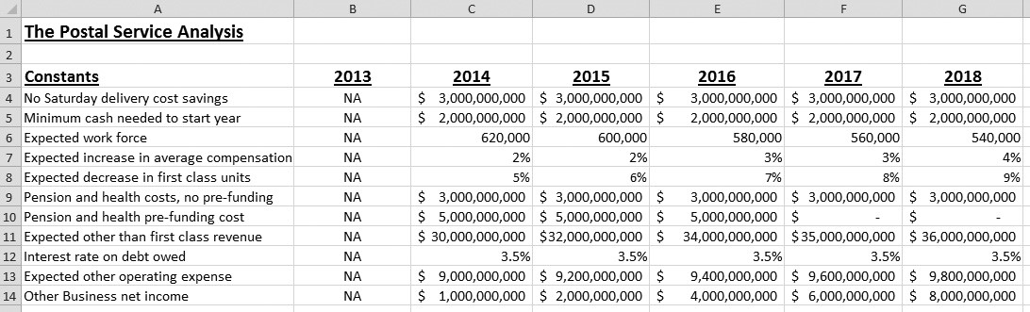
FIGURE 7-1
Constants section
- No Saturday delivery cost savings—If Saturday delivery were discontinued, operating expenses would be $3 billion less each year.
- Minimum cash needed to start year—The postal service wants to have at least $2 billion in cash at the beginning of each year. The government will lend the amount needed at the end of a year to begin the new year with that amount.
- Expected work force—By attrition, 20,000 workers will be lost each year. This attrition will reduce compensation expenses each year.
- Expected increase in average compensation—Union agreements call for wage increases each year. Expected percentage increases in average compensation are shown.
- Expected decrease in first class units—The postal service will continue to feel the impact of the Internet on first-class mail. This field shows the expected percentage decrease in items sent first class each year.
- Pension and health costs, no pre-funding—The “normal” provision for pension and retiree health care is expected to be $3 billion a year.
- Pension and health pre-funding cost—The added cost for future pension and retiree healthcare “pre-funding” is expected to be $5 billion a year through 2016.
- Expected other than first class revenue—The postal service does more than deliver first-class mail. The postal service provides shipping and packaging services, handles “junk” mail, delivers periodicals, and provides other mail-related services. In total, these aspects of the postal service are expected to grow. Expected revenue for each year is shown.
- Interest rate on debt owed—The government acts as the postal service’s banker. The average interest rate on existing debt is 3.5 percent. For planning purposes, the government would charge this interest rate for any new borrowing.
- Expected other operating expense—Other out-of-pocket expenses, such as costs that do not involve compensation or transportation, are expected to grow each year, as shown.
- Other Business net income—Profits will accrue if the postal service is allowed to branch into new businesses. The value of estimated new revenue minus added expenses will be low in early years, but it is projected to grow as time goes on, as shown.

Inputs Section
Your spreadsheet should include the following inputs for the years 2014 to 2018, as shown in Figure 7-2.
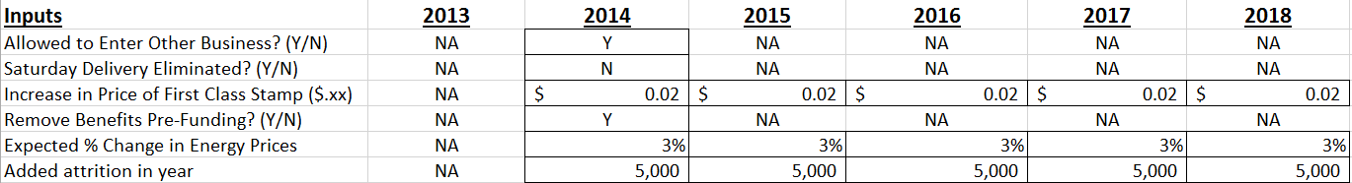
- Allowed to Enter Other Business? (Y/N)—Enter Y if the legislature will permit this policy, and N if not. The entry applies to all five years.
- Saturday Delivery Eliminated? (Y/N)—Enter Y if the legislature will permit this policy, and N if not. The entry applies to all five years.
- Increase in Price of First Class Stamp ($.xx)—Enter a value for this increase each year. For example, if no increase is expected in any year, the entry would be .00, .00, .00, .00, .00. If a three-cent increase is expected each year, the entry would be .03, .03, .03, .03, .03. Cells should be formatted for Currency.
- Remove Benefits Pre-Funding? (Y/N)—Enter Y if the legislature will permit this policy, and N if not. The entry applies to all five years.
- Expected % Change in Energy Prices—Enter the percent change expected each year. For example, if a 2 percent increase is expected each year, enter .02, .02, .02, .02, .02. If no change is expected, enter five zeroes. Negative values would indicate that energy cost decreases are expected. Cells should be formatted for Percentage.
- Added attrition in year—Enter the number of workers expected to be laid off each year, above and beyond the already expected attrition. Do not enter a number of more than 20,000 in any year. If no added layoffs are expected, enter a zero.
- Set the Inputs to the following values to start. If you do not use these values, the calculation section will not match the answers on these pages.
  - The postal service is allowed to branch into other businesses.
  - Saturday service is not eliminated.
  - The price of a first-class stamp increases 2 cent per year in each of the years from 2014 to 2018.
  - Benefits pre-funding is eliminated; in other words, the postal service does not continue to pre-fund.
  - Energy prices increase only 3 percent per year in each of the years from 2014 to 2018.
  - Additional attrition of 5,000 occurs in each of the years from 2014 to 2018.

Summary of Key Results Section
For each year, your spreadsheet should show net income (or loss) in the year, cash on hand at the end of the year, and debt owed to the government at the end of the year. The net income, cash, and debt cells should be formatted as currency with zero decimals. These values are computed elsewhere in the spreadsheet and should be echoed here.

Calculations Section
You should calculate intermediate results that will be used in the income and cash flow statements that follow. Calculations, as shown in Figure 7-4, may be based on expected year-end 2013 values. When called for, use absolute referencing properly. Values must be computed by cell formula; hard-code numbers in formulas only when you are told to do so. Cell formulas should not reference a cell with a value of “NA.” An explanation of each item in this section follows the figure.
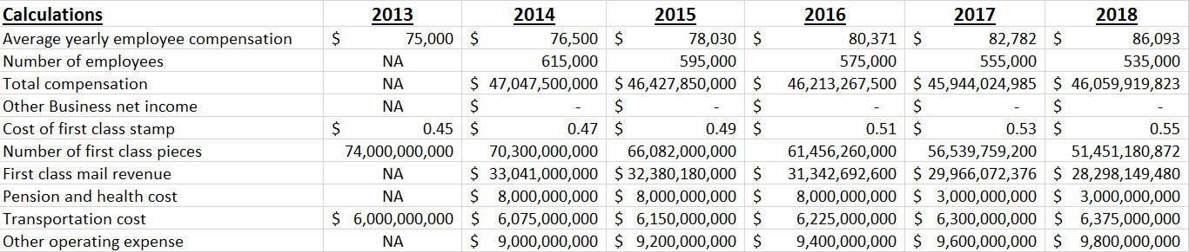
- Average yearly employee compensation—Almost all employees are unionized. The average compensation for all employees was $75,000 in 2013. The expected rate of compensation increase each year is shown in the Constants section. Format cells for currency and no decimals.
- Number of employees—This value is a function of the expected workforce (from the Constants section) and added attrition (from the Inputs section).
- Total compensation—This value is a function of the number of employees and the average yearly compensation. Both of these values are from the Calculations section.
- Other Business net income—This amount will be earned if the postal service is allowed to branch into new businesses, as indicated by the value in the Inputs section. The amount is shown in the Constants section.
- Cost of first class stamp—A stamp cost 45 cents in 2013. The increase each year is shown in the Inputs section.
- Number of first class pieces—A total of 74 billion pieces of mail were delivered in 2013. The number is expected to decrease each year by a percentage shown in the Constants section.
- First class mail revenue—This value is a function of the price of a first-class stamp and the number of first-class pieces. Both values are taken from the Calculations section. Format cells for currency and no decimals.
- Pension and health cost—The base cost and the pre-funding increment are shown in the Constants section. A value in the Inputs section indicates whether the pre-funding cost will be eliminated. Format cells for currency and no decimals.
- Transportation cost—The transportation cost in 2013 was $6 billion. The cost each year will remain at $6 billion unless energy prices change. The expected percentage change each year is shown in the Inputs section. For each 1 percent increase in price, transportation costs will increase $25 million. For example, a +2 percent change is expected in 2014. Transportation costs in 2014 will be $6 billion + (2 × $25 million), or $6,050,000,000.
- Other operating expense—If Saturday delivery is eliminated, the expense shown in this field will be the expected other operating expenses minus the Saturday savings. Both of these values are from the Constants section.

Income and Cash Flow Statements
The forecast for net income and cash flow starts with the cash on hand at the beginning of the year. This value is followed by the income statement and the calculation of cash on hand at year’s end. For readability, format cells in this section as currency with zero decimals. Values must be computed by cell formula; hardcode numbers in formulas only if you are told to do so. Cell formulas should not reference a cell with a value of “NA.” Your spreadsheets should look like those figures below. A discussion of each item in the section follows each figure.
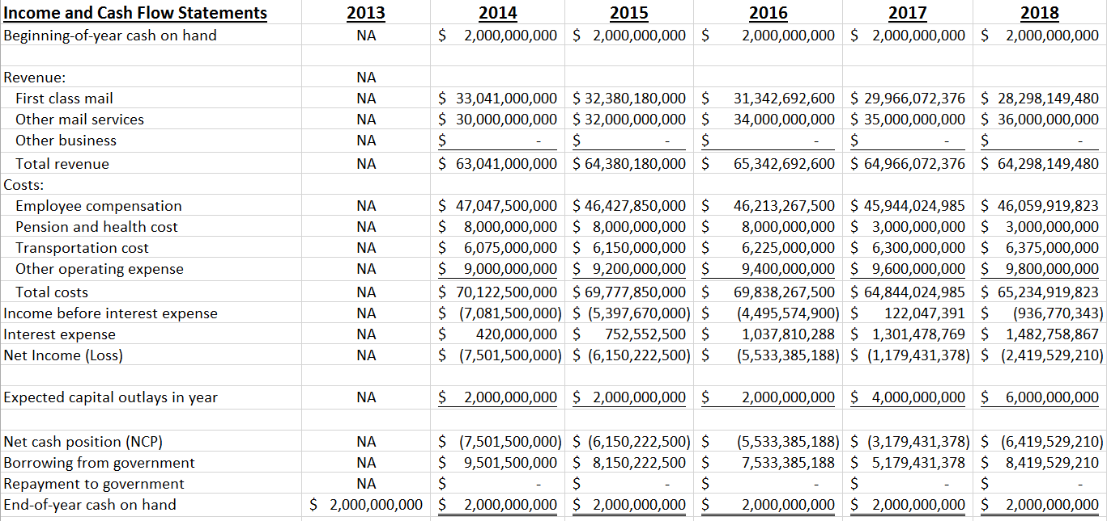
- Beginning-of-year cash on hand—This value is the cash on hand at the end of the prior year.
- First class mail revenue—This amount is from the Calculations section and can be echoed here.
- Other mail services revenue—This amount is from the “Expected other than first class revenue” value in the Constants section and can be echoed here.
- Other business revenue—This amount is from the Other Business net income value in the Calculations section and can be echoed here.
- Total revenue—This amount is the sum of first-class, other mail service, and other business revenues.
- Employee compensation—This amount is from the Calculations section and can be echoed here.
- Pension and health cost—This amount is from the Calculations section and can be echoed here.
- Transportation cost—This amount is from the Calculations section and can be echoed here.
- Other operating expense—This amount is from the Calculations section and can be echoed here.
- Total costs—This amount is the total of employee compensation costs, pension and health costs, transportation costs, and other operating costs.
- Income before interest expense—This amount is the difference between total revenue and total costs.
- Interest expense—This amount is the product of the debt owed to the government at the beginning of the year and the interest rate for the year. The interest rate is a value in the Constants section.
- Net Income (Loss)—This amount is the difference between income before interest expense and interest expense. The postal service does not pay income taxes, so there is no line for Net Income After Taxes.
- Expected capital outlays in year—These amounts are expected to be $2 billion in 2014, 2015, and 2016, $4 billion in 2017, and $6 billion in 2018. You can hard-code these values in the cells.
- Net cash position (NCP)—The NCP at the end of a year equals the cash at the beginning of the year, plus the year’s net income (or loss), minus the year’s capital outlay.
- Borrowing from government—Assume that the government will lend enough money at the end of the year to reach the minimum cash needed to start the next year. If the NCP is less than this minimum, the postal service must borrow enough to start the next year with the minimum. Borrowing increases the cash on hand, of course.
- Repayment to government—If the NCP is more than the minimum cash needed and some debt is owed at the beginning of the year, as much debt as possible must be paid off (but do not take cash below the minimum amount required to start the next year). Repayments reduce cash on hand, of course.
- End-of-year cash on hand—This amount is the NCP plus any borrowing, and minus any repayments.

Debt Owed Section
This section shows a calculation of debt owed to the government at year’s end, as shown in Figure 7-7. Year 2013 values are NA except for End-of-year debt owed, which is $12 billion. Values must be computed by cell formula; hard-code numbers in formulas only when you are told to do so. Cell formulas should not reference a cell with a value of “NA.” An explanation of each item follows the figure.
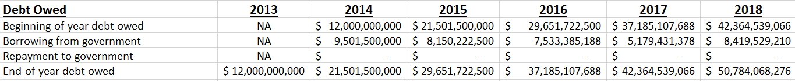
- Beginning-of-year debt owed—Debt owed at the beginning of a year equals the debt owed at the end of the prior year.
- Borrowing from government—This amount has been calculated elsewhere and can be echoed to this section. Borrowing increases the amount of debt owed.
- Repayment to government—This amount has been calculated elsewhere and can be echoed to this section. Repayments reduce the amount of debt owed.
- End-of-year debt owed—In 2014 through 2018, this is the amount owed at the beginning of the year, plus borrowing during the year, and minus repayments during the year.
Creating Charts
Using the following inputs, create two charts:
  - The postal service is allowed to branch into other businesses.
  - Saturday service is not eliminated.
  - The price of a first-class stamp increases 2 cent per year in each of the years from 2014 to 2018.
  - Benefits pre-funding is eliminated; in other words, the postal service does not continue to pre-fund.
  - Energy prices increase only 3 percent per year in each of the years from 2014 to 2018.
  - Additional attrition of 5,000 occurs in each of the years from 2014 to 2018.
- The first chart should compare the data in the results section for the years 2014-2018.
  - Column Chart
  - The horizontal axis should have the years and the series should be Net Income, End of Year Cash on Hand, and End of Year Debt Owed.
  - Make sure that the chart is self-explanatory by uses axis titles, legends, chart title, and any other options that may further explain the chart.
- The second chart should compare the costs for years 20124-2018.
  - Line Chart
  - The horizontal axis should have the years and the series should be the Costs. Make sure that you do NOT include the Total Costs.
  - Make sure that the chart is self-explanatory by uses axis titles, legends, chart title, and any other options that may further explain the chart.

ASSIGNMENT 2: USING THE SPREADSHEET FOR DECISION SUPPORT

Complete the case by (1) using the spreadsheet to gather data about possible scenarios and (2) documenting your findings in a memo.
Postal service management wants to know projected financial results in three different scenarios:
- No operational or financial changes occur. Presumably, further losses will occur in this scenario. How bad will the debt load get?
- Aggressive changes are made. This would require intensive negotiations with the union and the legislature. Will profitability be restored and debt eliminated?
- Some “middling” changes are made. This would require some negotiations. Will profitability be restored and debt eliminated?
Each scenario is explained in the following sections.

Scenario #1: No changes
The first scenario is called “No Change.” In this scenario:
- The postal service is not allowed to branch into other businesses.
- Saturday service is not eliminated.
- The price of a first-class stamp increases 1 cent per year in each of the years from 2014 to 2018.
- Benefits pre-funding is not eliminated; in other words, the postal service must continue to pre-fund.
- Energy prices increase only 1 percent per year in each of the years from 2014 to 2018.
- No additional attrition occurs in any of the years from 2014 to 2018.

Scenario #2: Aggressive
The second scenario is called “Aggressive.” In this scenario:
- The postal service is allowed to branch into other businesses.
- Saturday service is eliminated.
- The price of a first-class stamp increases 3 cents per year in each of the years from 2014 to 2018.
- Benefits pre-funding is eliminated; in other words, the postal service does not continue to pre-fund.
- Energy prices increase only 1 percent per year in each of the years from 2014 to 2018.
- Additional layoffs (added attrition) of 20,000 occur in each of the years from 2014 to 2018.

Scenario #3: Middling
The third scenario is called “Middling.” In this scenario:
- The postal service is allowed to branch into other businesses.
- Saturday service is not eliminated.
- The price of a first-class stamp increases 2 cents per year in each of the years from 2014 to 2018.
- Benefits pre-funding is eliminated; in other words, the postal service does not continue to pre-fund.
- Energy prices increase 3 percent per year in each of the years from 2014 to 2018.
- Additional layoffs (added attrition) of 5,000 occur in each of the years from 2014 to 2018.
Can adequate profitability and reasonable debt levels be achieved with less intensive negotiating? If so, the aggressive scenario need not be pursued.
In each scenario, management wants to know the projected 2018 net income and projected 2018 cash on hand. In each scenario, management also wants to know the debt owed at the end of each of the years from 2014 to 2018, and whether projected debt levels ever exceed the $15 billion threshold.

Assignment 2A: Using the Spreadsheet to Gather Data
You have built the spreadsheet to model the business situation. For each of the three scenarios, you want to know the 2018 net income after taxes, the 2018 end-of-year cash on hand, and the end-of-year debt owed for each of the years 2014 through 2018 (Colored Orange).
You will run “what-if” scenarios with the three sets of input values using Scenario Manager. Set up the three scenarios. Note that in Scenario Manager you can enter noncontiguous cell ranges, such as C19, D19, C20:F20.(Colored Yellow)
The relevant output cells are the 2018 net income and end-of-year cash on hand cells, and the end-of-year debt owed cells for 2014 through 2018 in the Summary of Key Results section. Run Scenario Manager to gather the data in a report. Save the spreadsheet file a final time.

Assignment 2B: Documenting Your Recommendations in a Memo
Use Microsoft Word to write a brief memo documenting your analysis and conclusions. Observe the following requirements:
- Use one of the memo templates in Word. Address it to your instructor.
- In the first paragraph, briefly state the business situation and the purpose of your analysis.
- Next, provide the answers to management’s questions. What will happen if there are no changes? If there are no changes, what stamp price increase would be needed to restore profitability and reduced debt levels? Is an Aggressive strategy needed, or can a Middling strategy succeed?
- State your recommendation. What strategy, if any, should postal service management pursue?
- Support your statements graphically, as your instructor requires. Your instructor may ask you to return to Excel and copy the Scenario Manager summary sheet results into the memo. Your instructor might also ask you to make a summary table in Word based on the Scenario Manager summary sheet results. Your table should resemble the format shown below.
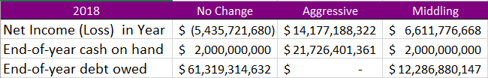

DELIVERABLES

Your completed case should include the following deliverables uploaded to Canvas:
- Electronic copies of all your work, including your Word memo and Excel DSS model.
- Make sure the workbook contains the following:
  - Formulas and functions
  - Scenario manager results as a separate worksheet
  - Scenario manager Summary Table.
  - Charts each on separate worksheet
- Make sure the memo contains the two charts and the Scenario Manager Summary Table.

